Avoidable ED Visit ML Project
Overview
This project develops a machine learning pipeline to predict avoidable emergency department (ED) visits using Medicare claims data.
The Centers for Medicare and Medicaid Services (CMS) Synthetic Medicare Enrollment, Fee for-Service Claims, and Prescription Drug Event Data Public Use File (Synthetic Medicare Claims PUFs) is a synthetic dataset representing enrollment information and healthcare claims for 8,671 Medicare beneficiaries between the ages of 0 and 110.
- Load data
- Dataset: CMS Synthetic Medicare Enrollment and Fee-for-Service Claims data
- Population: 8,671 synthetic Medicare beneficiaries (ages 0–110)
- Scope: Enrollment and claims (diagnoses, procedures, revenue center codes, payments)
- Database and normalization
- Database: PostgreSQL
- Normalized tables:
    - Diagnosis
    - Procedure Code
    - Claims
    - Revenue
    - Beneficiary
- Connection and environment
    - Connection via SQLAlchemy with environment variables: POSTGRES
- Visit-level reconstruction (SQL)
- Identified ER claims using:
    - Revenue center codes: 0450–0459, 0981
    - ED E/M CPT/HCPCS codes: 99281–99285
- Joined across tables:
    - Claims ↔ Beneficiary on BENE_ID and YEAR
    - Claims ↔ Diagnosis on CLM_ID
    - Diagnosis ↔ ICD10_ChronicIndicator on ICD10
    - Diagnosis ↔ ED_Algorithm_ICD10 on ICD10
    - Diagnosis ↔ CCSR_ICD10 on ICD10
- Rolled up to visit level:
    - Partition by beneficiary, facility, year, and claim start date
    - Visit start = MIN(CLM_FROM_DT), visit end = MAX(CLM_THRU_DT)
    - Payment aggregation: SUM(CLM_PMT_AMT)
    - Claim count per visit: COUNT(DISTINCT CLM_ID)
- Body system indicators derived from CCSR Body System
- Year extracted from visit start timestamp
- Target variable:
    - Probably of avoidable ED Visit
- Visit-level modeling dataset:
    - er_visits_modeling_dataset.parquet
- Final modeling table columns
  - Numeric features:
    - AGE_AT_END_REF_YR
    - total_paid_amt
    - primary_dx_chronic_flag
    - bodysystem_respiratory
    - bodysystem_circulatory
    - bodysystem_infectious
    - bodysystem_digestive
    - bodysystem_mentalbehavioral
    - bodysystem_musculoskeletal
    - bodysystem_neoplasms
    - bodysystem_nervoussystem
    - bodysystem_injurypoisoning
    - bodysystem_skin
    - bodysystem_genitourinary
    - bodysystem_endocrine
    - bodysystem_bloodimmune
    - bodysystem_symptoms
    - bodysystem_externalcauses
    - bodysystem_congenital
    - bodysystem_perinatal
    - bodysystem_pregnancy
    - bodysystem_dental
    - bodysystem_eye
    - bodysystem_ear
    - bodysystem_healthstatus
    - bodysystem_unacceptable
  - Categorical features:
    - SEX_IDENT_CD
    - BENE_RACE_CD
    - YEAR
  - Target:
    - Avoidable_ED_Visit

- Clean, Preprocess, and Explore Data
- Data Cleaning
- Missing values: Minimal due to SQL joins with COALESCE.
- primary_dx and all BodySystem_* indicators are complete.
- Categorical casting: Converted SEX_IDENT_CD, BENE_RACE_CD, and YEAR to string.
- High cardinality removed: primary_dx.
- Contaminated removed: STATE_CODE.
- Preprocessing Strategy
- Numeric features:
- AGE_AT_END_REF_YR → StandardScaler
- total_paid_amt → Log1p transform + MinMaxScaler
- OneHotEncoder for SEX_IDENT_CD, BENE_RACE_CD, YEAR
- Body system indicators:
- StandardScaler applied to binary flags
- Exploratory Data Analysis
- Class Balance
- Target Avoidable_ED_Visit is imbalanced (~9.5% positive).
- Stratified train/test split required to preserve proportions.
- Demographics
  - SEX_IDENT_CD: ~56% male, ~44% female.
  - BENE_RACE_CD: Majority White (code 1), followed by Hispanic (5) and Black (2).
  - AGE_AT_END_REF_YR: Skewed toward older adults (expected for Medicare).
- Numeric Features
  - total_paid_amt: Extremely right-skewed with large outliers (> $500k).
  - Log transformation applied.
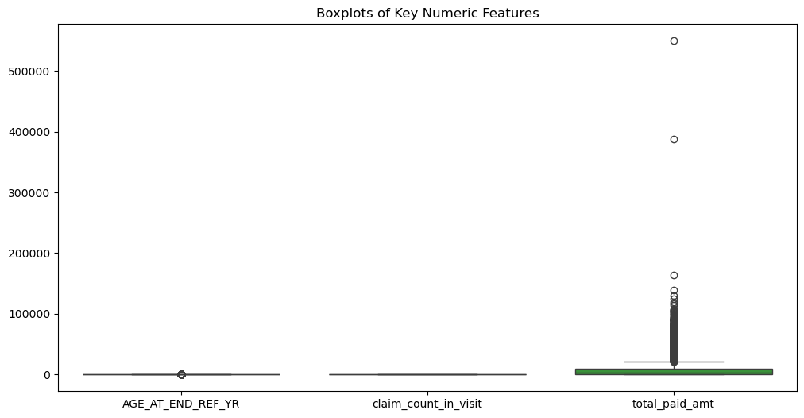
- Correlation Analysis
  - moderate associations among body system indicators.
  - No single numeric feature strongly predicts avoidable ED visits alone.
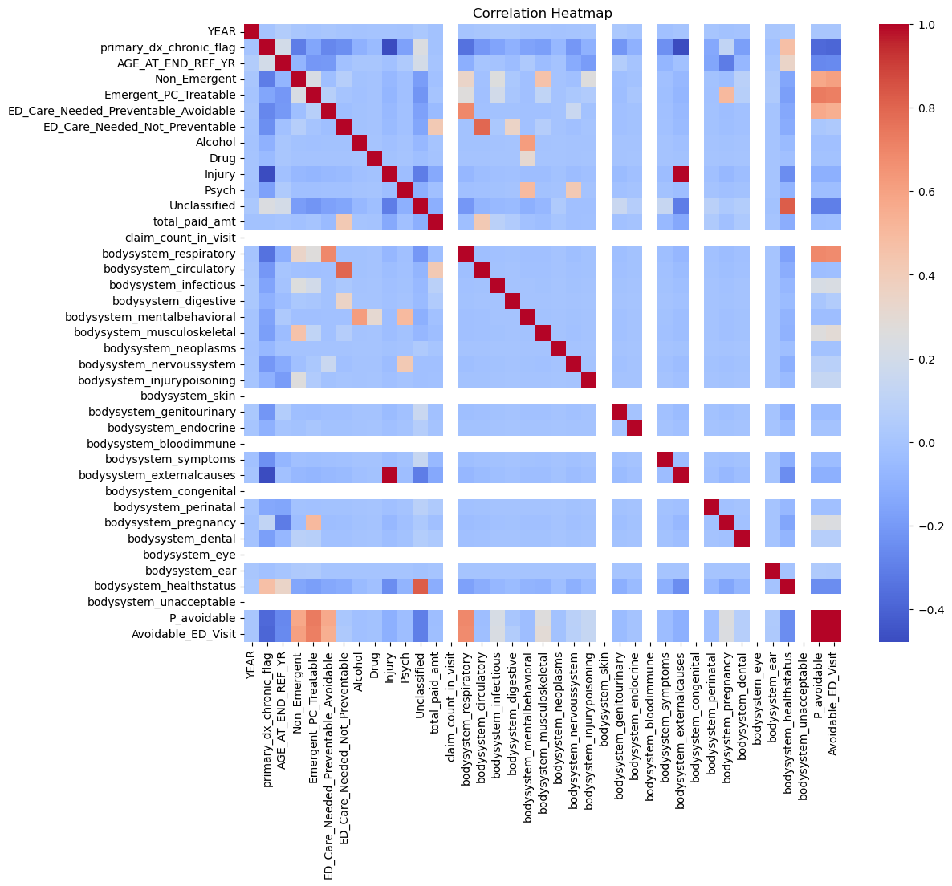

- Outliers
  - Boxplots confirm extreme outliers in total_paid_amt.
  - Decision: log transform only, keep outliers.
- Visualizations included
  - Histograms and Boxplots
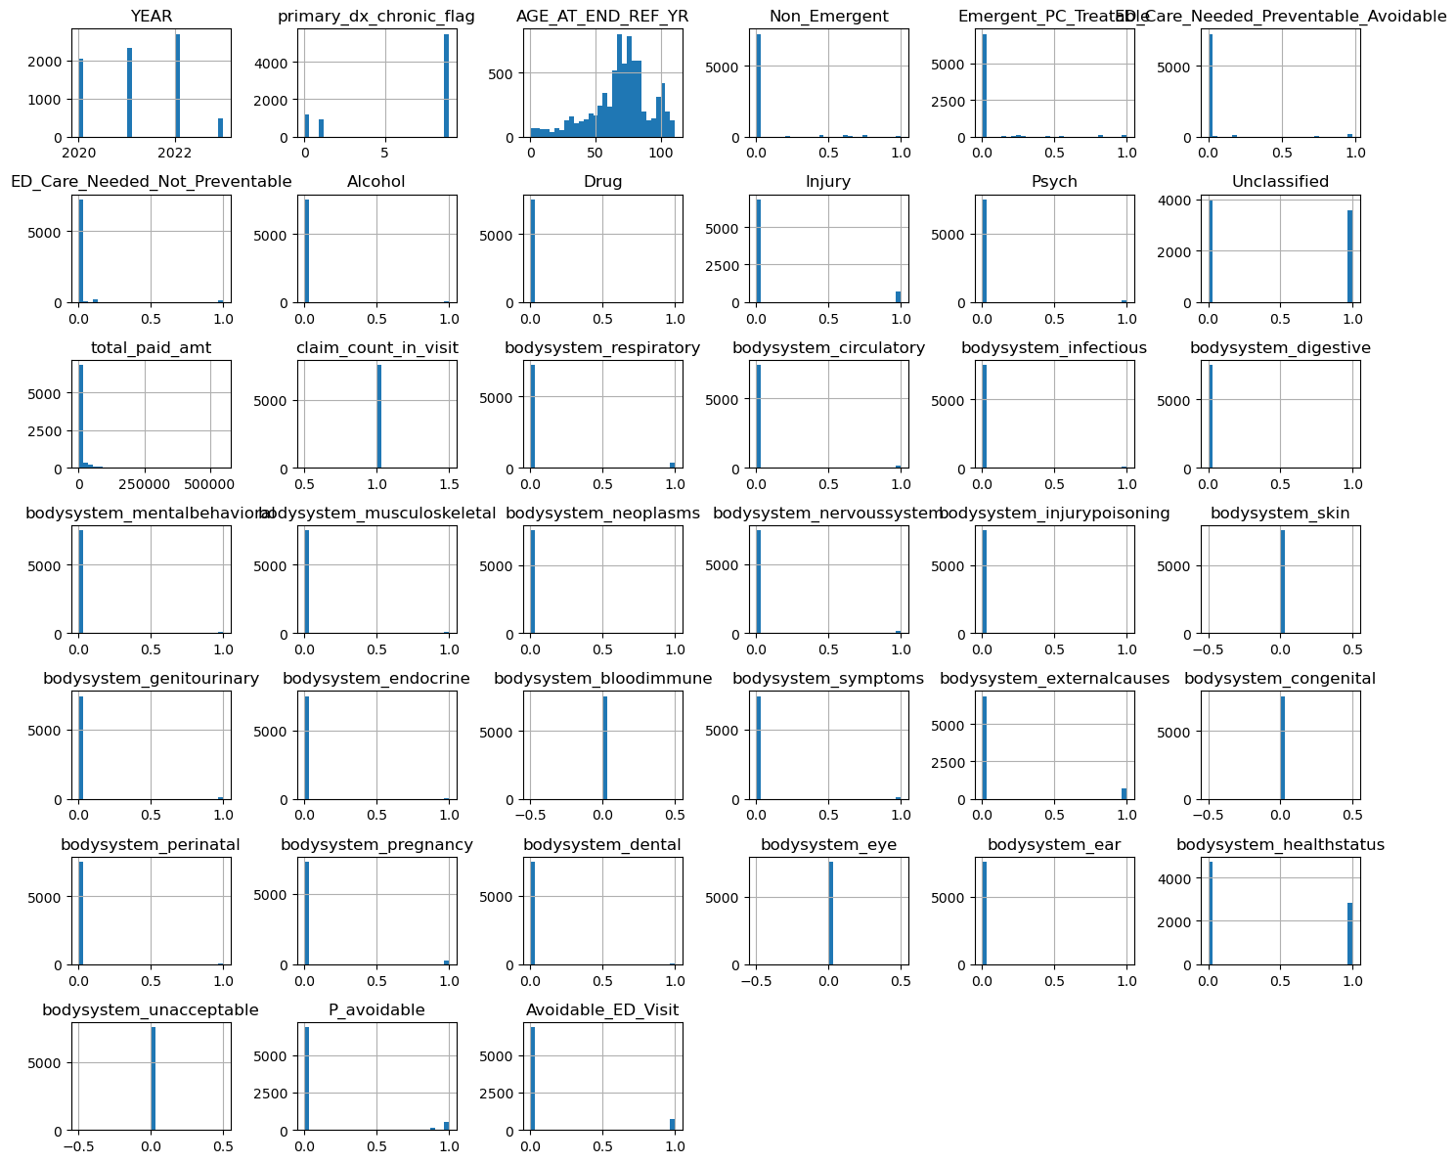
- Automated profiling report (ydata-profiling)
- Cleaned dataset: modeling_dataset_clean.parquet
- EDA figures: histograms, boxplots, correlation heatmap
- Profiling report: eda_profile.html (optional, generated with ydata-profiling)
  - Avoidable ED visits are rare (~9.5%).
  - Demographics skew older, majority White.
  - Costs are highly skewed with extreme outliers.
  - Body system indicators provide clinically meaningful predictors.
  - Stratified sampling required for modeling.

- Train Models
- Baseline Algorithm: Logistic Regression (No PCA + With Tuning)
- Logged in MLflow/Dagshub for reproducibility.
- Experiment Framework
  - Algorithms tested:
  - Logistic Regression, Ridge Classifier, Random Forest, XGBoost.
- Conditions:
  - No PCA + No Tuning
  - No PCA + With Tuning (GridSearchCV)
  - PCA + No Tuning
  - PCA + With Tuning (Optuna)
- Total: 16 experiments, all tracked in MLflow/Dagshub.
  - Dagshub MLflow Experiments
- Experiment tracking: Dagshub MLflow Experiments
- Evaluation Metrics
  - Primary metric: F1 score
- Logging: All metrics and trained models logged to MLflow.
- Best Model
  - Experiment: experiment 2 randomforest
  - Test F1: 0.862
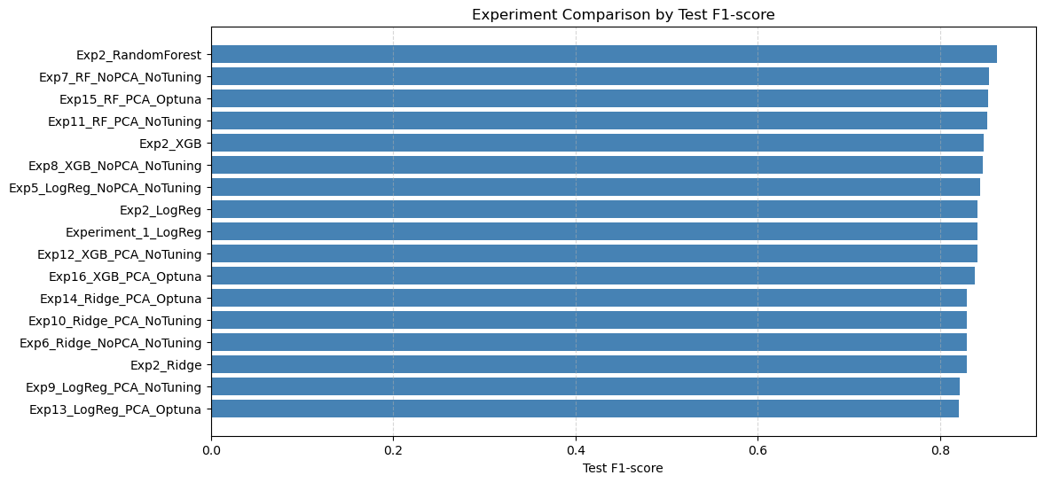
- Deploying final model
- Deployment
- Containerization: Final model + FastAPI packaged in Docker.
- Hosting: API served on Render; Streamlit UI hosted separately.
- Artifacts tracked: Image in Docker Hub; API docs exposed via OpenAPI (Swagger).
- FastAPI service
- Docs: https://avoidable-ed-api.onrender.com/docs#/default/predict_predict_post
- Prediction endpoint: POST /predict
- Docker image
- Docker Hub: https://hub.docker.com/repository/docker/menna1996/avoidable-ed-api/general
- Pull and run locally:
bash
docker pull menna1996/avoidable-ed-api:latest
docker run -p 8000:8000 menna1996/avoidable-ed-api:latest
- Streamlit app
- Live app: https://avoidableedmlproject-9rjakchaxjnarv3xq5dzhp.streamlit.app/
- Features:Form input:
  - Demographics, year, costs, body system indicators.
  - Real-time prediction: Calls FastAPI /predict endpoint.

